Canada Wide Science Fair 2019 Results
Science Team NL Rock the National Science Fair Competition
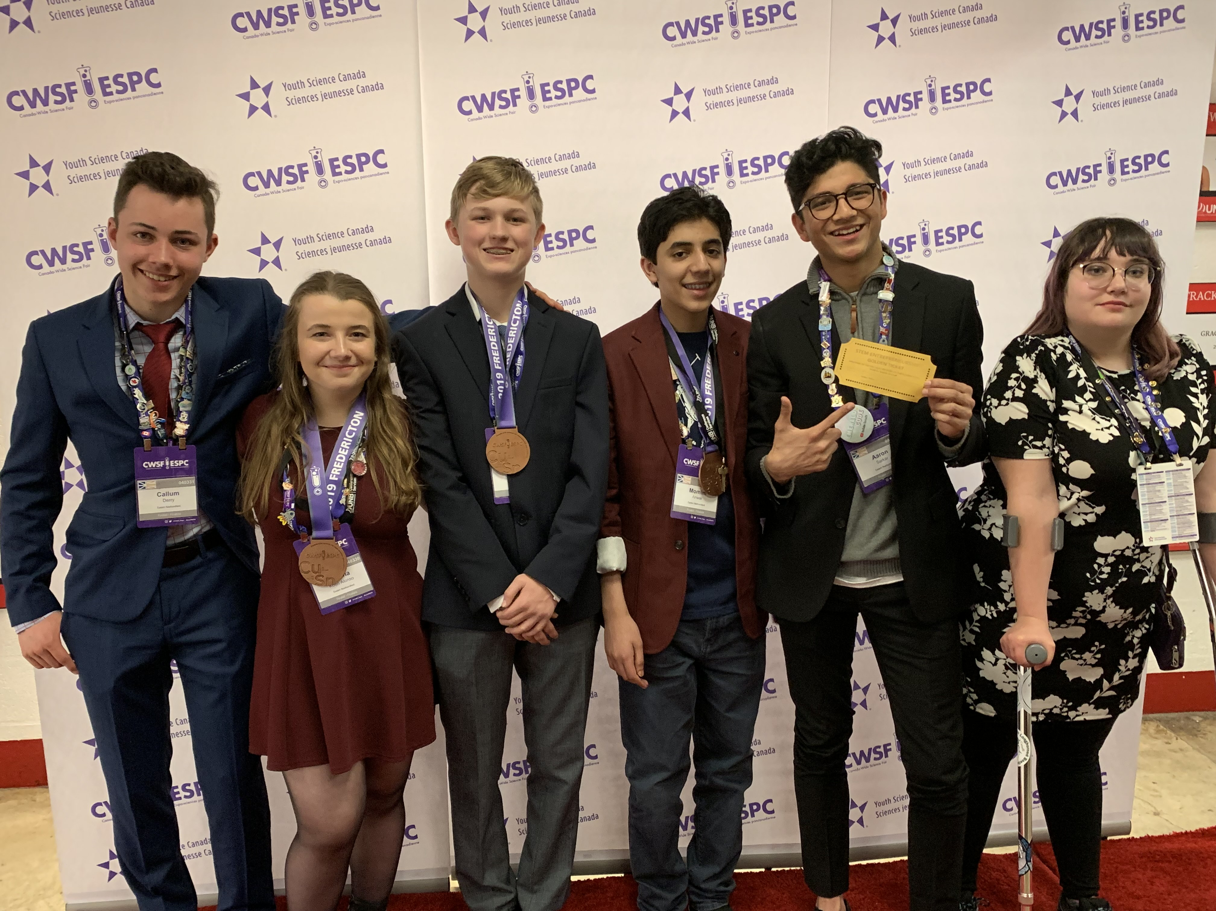

Science team NL: Callum Derry, Juliana Koen-Alsonso, Henley Mullins, Momin Anwar, Aaron Sarkar, Samantha Keats

Congratulations to the 6 students who proudly represented our province at the Canada Wide Science Fair in Fredericton, N.B. in May. Students were selected from 158 young scientists who competed at the 2019 Husky Energy Eastern Newfoundland Science and Technology Fair in April. The team included Samantha Keats from Holy Spirit, Henley Mullins from St. Bonaventure’s College, as well as Momin Anwar, Juliana Koen-Alonso, Callum Derry and Aaron Sarkar, all students from Holy Heart. The students spent a week at the University of New Brunswick along with chaperones, Ms. Stephanie Gallant and Mr. Jamie Parsons. The national fair brings together approximately 500 junior and senior high students from all provinces and territories. Juliana, Henley and Momin each won a bronze medal while Aaron was invited to the STEM Entrepreneurship Bootcamp this summer, sponsored by York University and BEST (Bergeron Entrepreneurs in Science and Technology). In addition, all medal winners were offered entrance scholarships to a number of Canadian Universities including Western University (London, Ontario) and the University of Ottawa.

